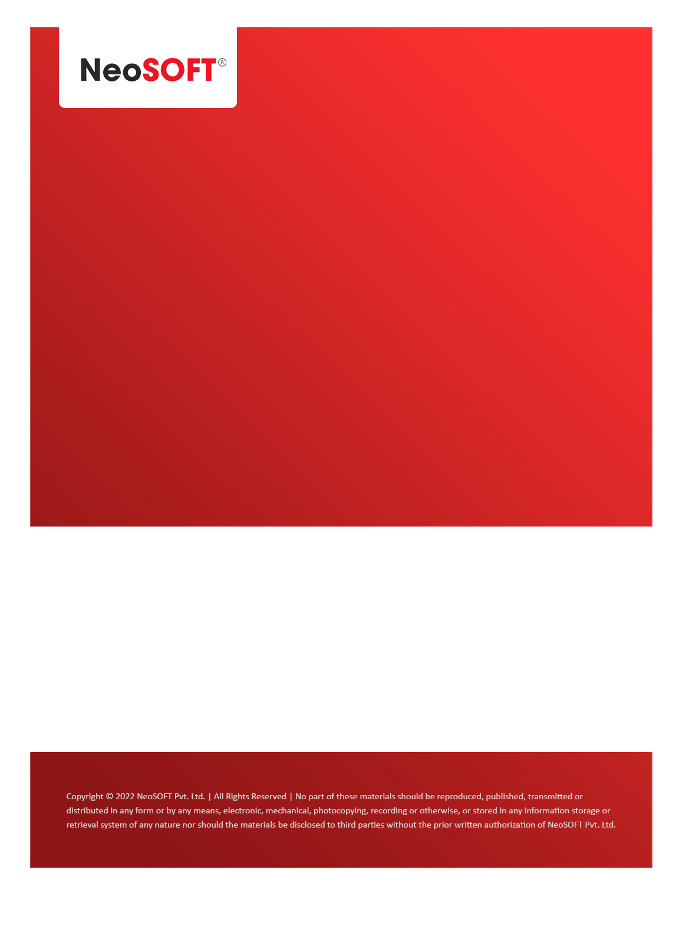`

**Eltizam MOM – Design review**

Eltizam

Client Name

NeoSOFT is a SEI-CMMI Level-5 Global IT Consulting & Software Solutions Provider

**20th July,** 2023

|  |  |
| --- | --- |
| **Meeting Date, Time, and Attendee Details** | |
| **Date** | 20th July 2023 |
| **Venue** | MS Teams |
| **Time** | 04.00 PM – 05.00 PM IST |
| **Meeting Type** | Project status discussions – Design phase |
| **Internal Attendees** | * YallaReddy * Aditya Jadhav * Karthik Natarajan |
| **Client Attendees** | * Karuna Pawar |
| **MOM Prepared By** | * Aditya Jadhav |
| **MOM Prepared By** | * YallaReddy |

|  |  |
| --- | --- |
| **Details of Meeting** | |
| **Sr. No.** | **Description** |
| 1 | Started design phase for the project & presented initial Figma design to Karuna. |
| 2 | Submitted initial screens of login, User page to get review from Vinod & team. Received initial feedback from Karuna regarding colour codes, themes. Expecting final feedback on user screen. |
| 3 | Requested Karuna to start discussion with business for new changes of Evaluation module. Also, informed that we can’t hold Akshata to this project from next week & will assign other BA resource. |
| 4 | Figma URL  <https://www.figma.com/file/XWYl9trSHWtPdOCUUsqbYj/EltizamWebAdminApp?type=design&node-id=100-26750&mode=design> |
| 5 | Figma Protocol URL <https://www.figma.com/proto/XWYl9trSHWtPdOCUUsqbYj/EltizamWebAdminApp?page-id=100%3A26750&type=design&node-id=100-26751&viewport=954%2C-96%2C0.13&t=CGOYlGwTzsReb6b9-1&scaling=scale-down&starting-point-node-id=100%3A26751> |

|  |  |  |  |  |  |
| --- | --- | --- | --- | --- | --- |
| **Actionable** | | | | | |
| **Sr. No.** | **Action Item** | **Assigned to** | **Assigned Date** | **Expected Completion Date** | **Status** |
| 1 | Expecting all feedback for User screen from Karuna & team. | Karuna & team |  |  |  |
| 2 |  |  |  |  |  |
|  |  |  |  |  |  |